LIGHT BLINKING

Link: <https://wokwi.com/projects/376373066477540353>

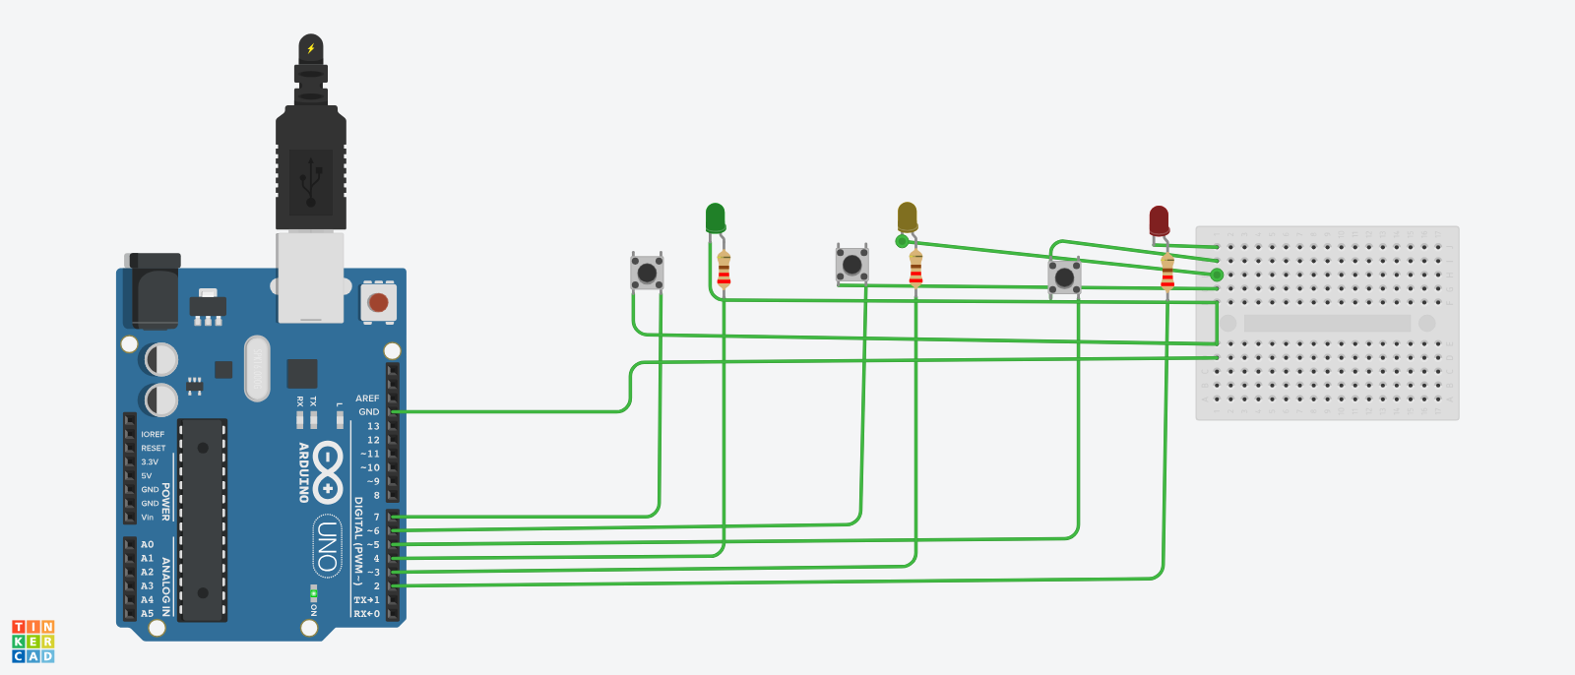TRAFFIC LIGHT CONTROLLER:

Link: <https://www.tinkercad.com/things/1q5l9DYkpbf-grand-amur/editel?sharecode=9_d_0PvX6uuTmaRIysYbgwnwhHbdEsihUv83fg4u3Xo>

GITHUB:

Link: <https://github.com/ChithambaramShiva/CHITHAMBARAM>